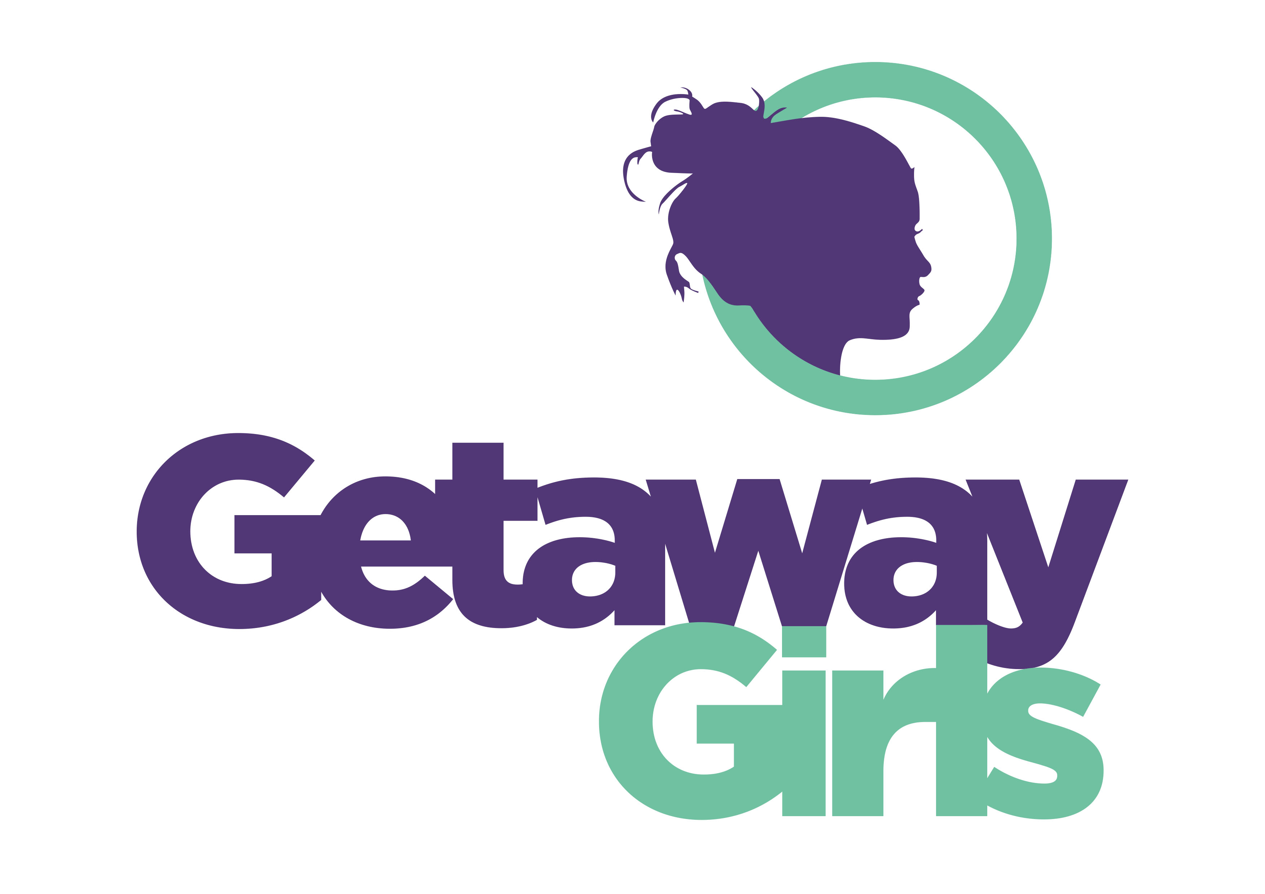JOB DESCRIPTION
JOB TITLE: Harehills Girls and Young women’s empowerment worker

37 hours . funded by National Lottery Reaching Communities till May 2030 ( 6 months probationary period)

POST TO WHICH DIRECTLY RESPONSIBLE: Services Manager

JOB PURPOSE:

The main role of this post is to plan, facilitate and evaluate groupwork programmes as part of the new Harehills Girls and Young women Thrive project.
Which is based at “The Hills”, our new young women’s space on Roundhay Road, Harehills.

Job Role / Responsibilities

- To work in partnership with organisations/ community projects within Harehills.

- To contact girls and young women to enable them to access groups and projects within Getaway Girls

- To plan, facilitate and evaluate new girls and young womens groups, projects and initiatives, which meet the needs of girls and young women in Harehills focusing on young women from black and global majority community.

- To support volunteers and peer educators to support groupwork programmes.

- To attend regular supervision, team meetings and training

- To maintain appropriate records on our OASIS system, evaluate work with young women and carry out the administration necessary to support the work

- To undertake any other duties as required by Getaway Girls

PAY SCALE: £27,612 pro rata

QUALIFICATION
3 years’ experience and relevant qualification or
willing to do Level 3 Training in Youth and Community work

ORGANISATIONAL REQUIREMENTS :

- Ability to work regular evenings and some weekends.
- Commitment to attend team meetings and team development days.
- To contribute to the daily smooth running of the organisation.
- To work within Getaway Girls values
- To abide by the rules & regulations in the staff handbook.
- To take responsibility for Health & Safety and risk assessments.

PERSON SPECIFICATION

JOB TITLE: Harehills Girls and Young Women’s worker

Detailed below are the types of skills, experience and knowledge that are required of applicants applying for the post. The ‘essential requirements’ indicate the minimum requirements and applicants lacking these attributes will not be considered for the post. The points detailed under ‘desirable requirements’ are additional attributes to enable the applicant to perform the position more effectively or with little or no training. They are not essential but may be used to distinguish between acceptable candidates.

SKILLS | essential | desirable | MOA
Ability to work with young women from a diverse range of backgrounds and needs | √ |  | AI
Ability to develop rapport with young women |  |  | AI
Ability to contact young women through outreach |  |  | AI
Can lead group work using a range of approaches |  |  | AI
Ability to organise projects, prioritise work and meet deadlines. |  |  | AI
Ability to work in partnership, on own initiative and within a team |  |  | AI
Ability to empower young women to participate within Voice and Influence opportunities |  |  | A

KNOWLEDGE OF/ QUALIFICATIONS | essential | desirable | MOA
Relevant qualification |  | √ | AC
Knowledge of barriers and inequalities young women face. |  |  | AI
Understanding of the ethos of young women centred work |  |  | AI
Knowledge of issues affecting girls and young women |  |  | AI
Knowledge of various IT packages. |  |  | A
Knowledge and understanding of confidentiality, equity and diversity and safeguarding |  |  | AI

EXPERIENCE | essential | desirable | MOA
Lead worker with at least 3 years’ experience of leading youth work opportunities |  |  | AI
Supporting young women from a diverse range of backgrounds and needs. Especially young women from black and global majority communities |  |  | AI
Outreach with young women |  |  | A
Working in partnership |  |  | AI
Working or living in Harehills |  | √ | AI

PERSONAL CHARACTERISTICS | essential | desirable | MOA
Commitment to the development of positive experiences for young women using young women centred approach |  |  | AI
A desire to learn from own and others experience |  |  | AI
Commitment to working within Getaway Girls values and policies |  |  | AI
Willing to work regular evenings and some weekends |  |  | AI
Enthusiastic and Motivated |  |  | AI

METHOD OF ASSESMENT
A = Application form
I = Interview
C = Certificate

