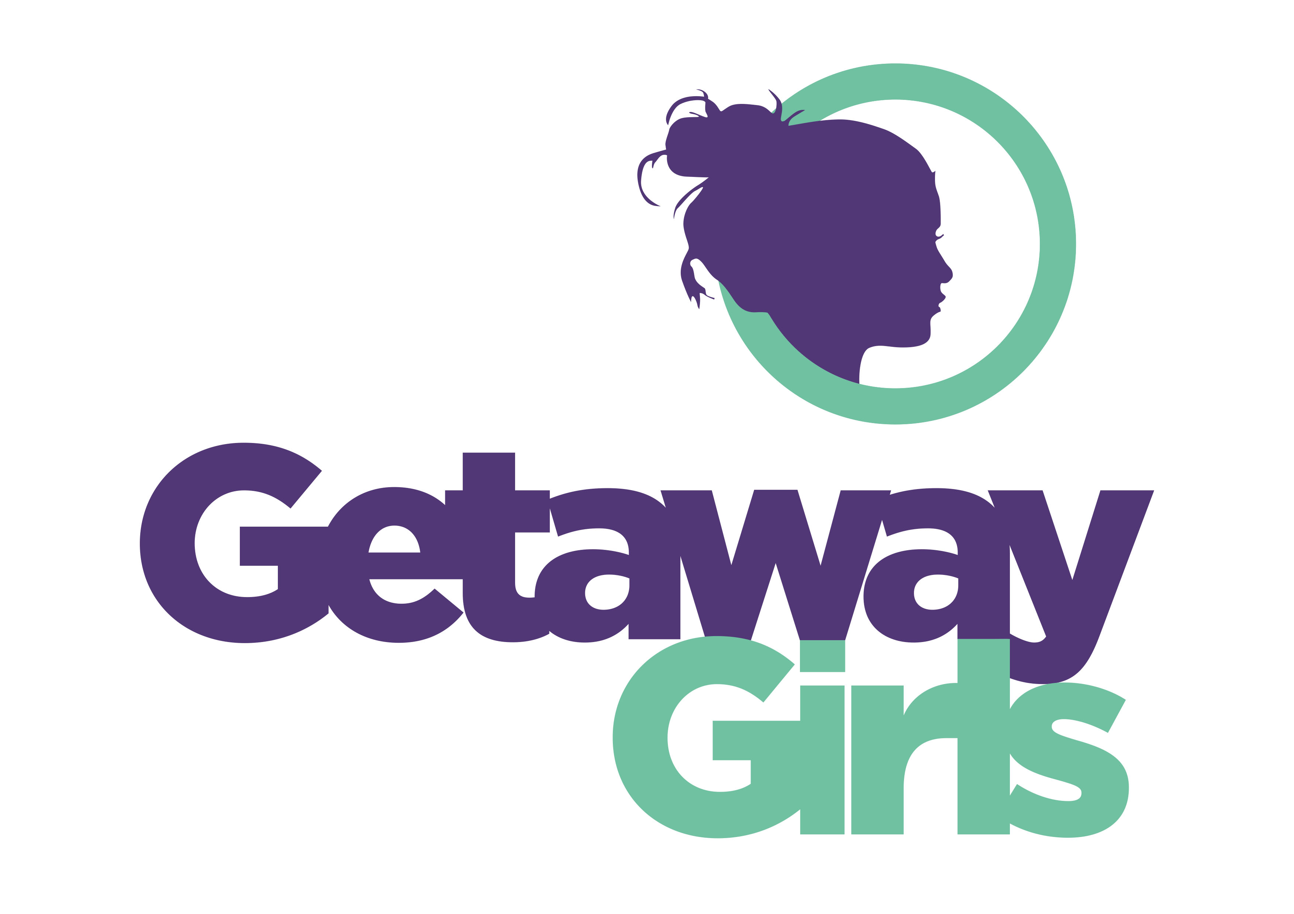

We are a values based young women’s charity committed to empowering girls and young women aged 8-25 in Leeds to build confidence, resilience, skills and aspirations.

You will have the opportunity to make a positive impact on the lives of young women.

We have 1 new role based at The Hills, our new young women’s space in Harehills funded by The National Lottery Reaching Communities Fund

- Harehills Girls and Young Women’s Empowerment worker
(Leading on the development of new groupwork programmes)

37 hours per week
Salary £27, 612
Funded till May 2030
(6 months probationary period)

To download an application pack, click on the link below: https://getawaygirls.co.uk/vacancies/

Closing date for both posts is 11th June 2026

Interview date 16th June 2026

Given the nature and requirements of this post, this post is open to women only and the Equality Act 2010 Schedule 9 (Part 1) Occupational Requirement applies

