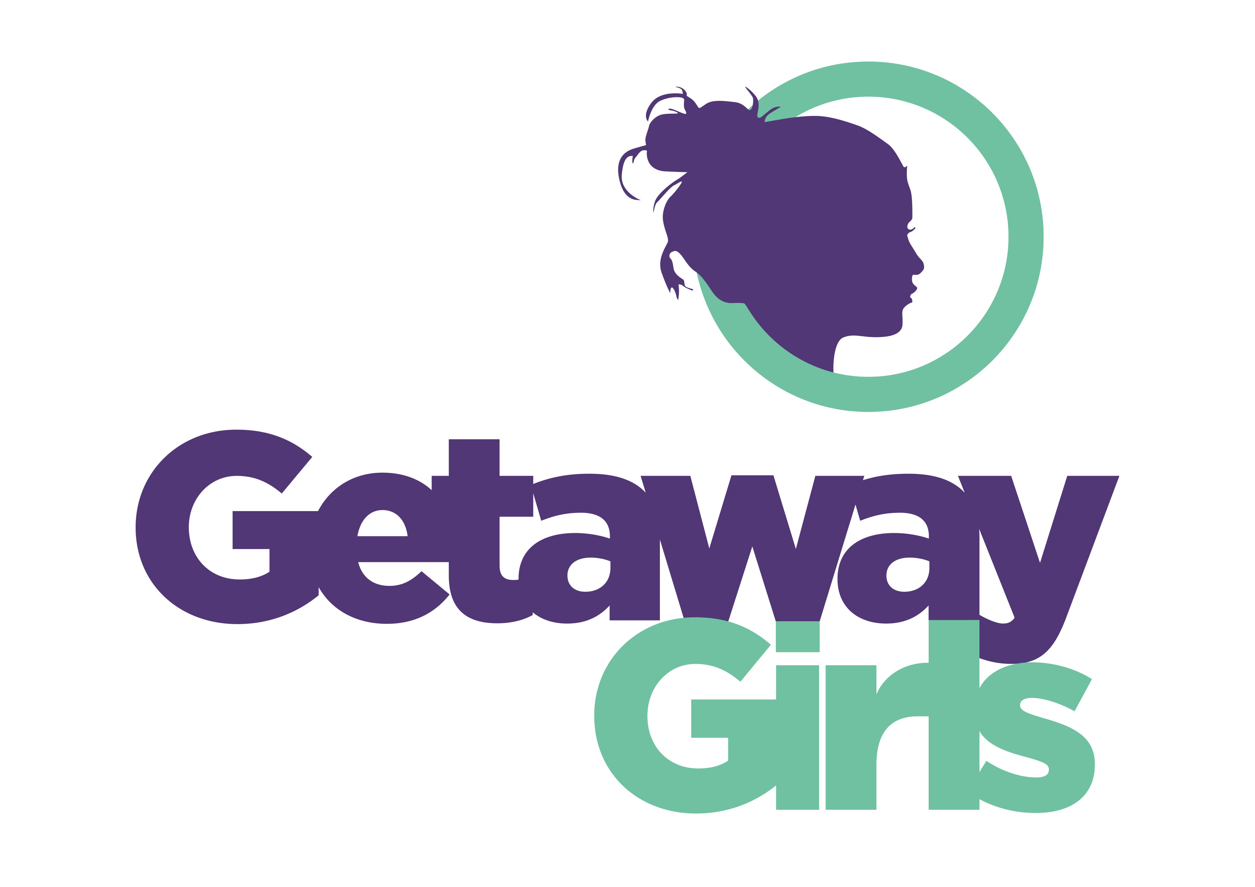

CRECHE WORKER JOB DESCRIPTION

ORGANISATION PROFILE

Getaway Girls empowers vulnerable young women aged 11-25 from Leeds to build confidence, develop new skills and take positive risks in an environment which offers co-operation and support.

We support women in groups including young women with children by offering a creche. Our crèche provision aims to offer a safe, creative, stimulating environment

To support children can grow, learn and have fun.

RATE OF PAY £13.40 per hour Sessional crèche worker.

KEY RESPONSIBILITIES

- To create and maintain a safe, creative and stimulating play environment.

- To plan, run and evaluate crèches for women’s groups, training and activity sessions at Getaway Girls

- To ensure carers are aware of crèche rules and responsibilities

- To maintain registration and other administrative information

- To maintain the safety of equipment and suitability for the age range covered

- To support play sessions for mums and children together in partnership with the young women’s development worker

- To produce profiles for all children and evaluate progress.

CRECHE WORKER EMPLOYEE SPECIFICATION

Skills

- Ability to build positive relationships with children and offer a safe, creative, stimulating environment to play
- Ability to build and maintain positive relationships with Carers/Parents

Knowledge

- A clear understanding of confidentiality
- An awareness of individual child’s needs
- Relevant qualifications and previous experience
- An understanding of Safeguarding Policy and Procedures

Qualifications

Childcare qualifications to level 3

